Dimensional Kd value of 1MN model

param beta=4, Km=0.1

param Ka=0.1

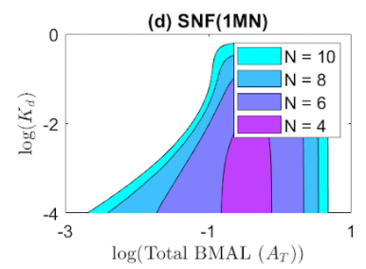

Step 1 Determine the largest Kd value for each N

Step 2 Calculate the dimensional Kd for each N

$$P^{*}=100nM/Ptot_max$$

$\hat{P}+{\hat{P}}_{5}+…+{\hat{P}}_{1}+{\hat{P}}_{\text{0}}$ is the non-dimensional Ptot

$${\hat{K}}_{\text{d}}=\frac{K_{\text{d}}}{P^{*}}$$

N=4, largest Kd = 0.01536

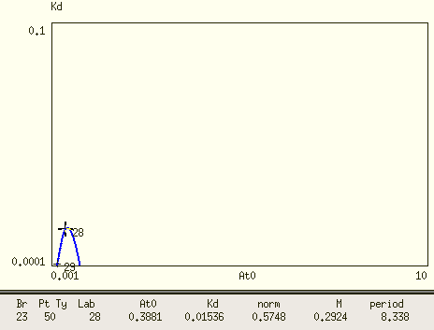

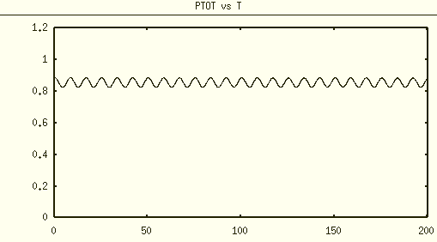

Ptot ~0.9

$P^{*}$ ≈ 111 nM

Dimensional Kd ~ 0.01536*111 = 1.7

N=6, largest Kd = 0.1625

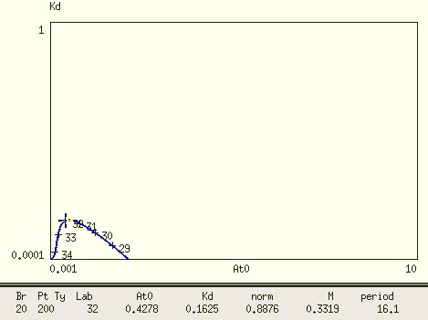

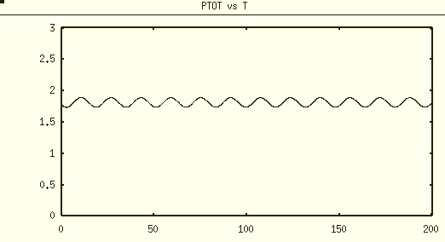

Ptot = 1.9

$$P^{*} ≈ 157894$$

$P^{*}$ ≈ 52.6 nM

Dimensional Kd ~ 0.1625*52.6 = 8.5475

N=8 largest Kd =0.3709

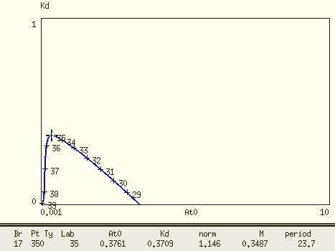

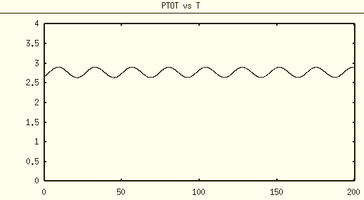

Ptot = 2.9

$P^{*}$ ≈ 34.48 nM

Dimensional Kd ~ 0.3709*34.48 = 12.78

N=10 largest Kd = 0.6173

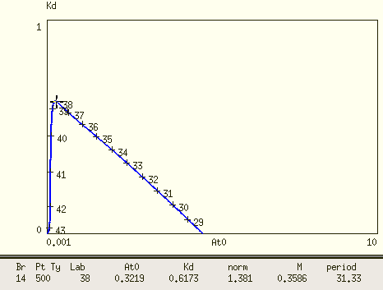

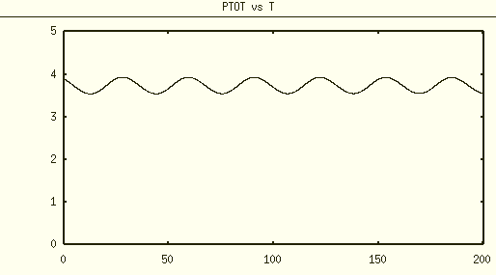

Ptot = 4

$P^{*}$ ≈ 25nM

Dimensional Kd ~ 0.6173*25 = 15.43

Summary

|  |  |
| --- | --- |
| N | Dimensional Kd |
| 4 | 1.7 |
| 6 | 8.55 |
| 8 | 12.78 |
| 10 | 15.43 |